

Day -1: Easy Programs (1-5)

Name: M. Sahasra
Reg. No.: 192425317
Course Code: CSA0919
Course Name: Programming in Java for Spring Framework
Faculty Name: Dr. Magesh Kumar

1. Reverse a Word Using Loop

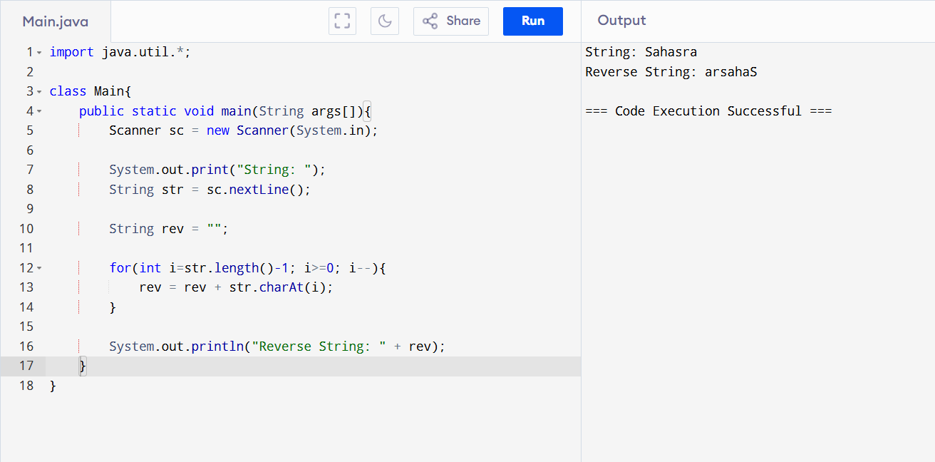

2. Convert String to Integer

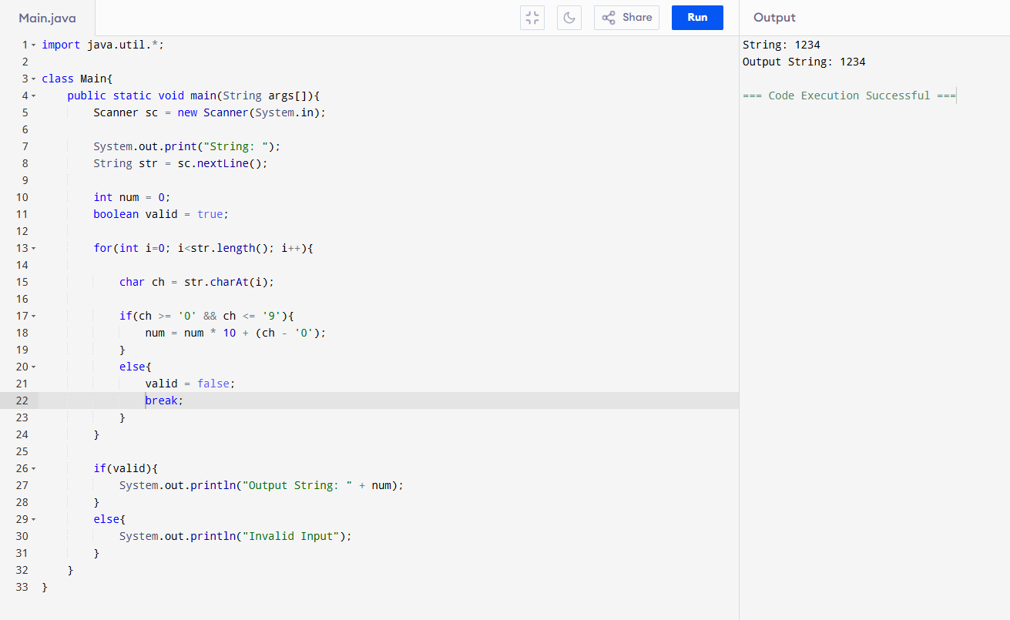

3. Check Username Valid or Not

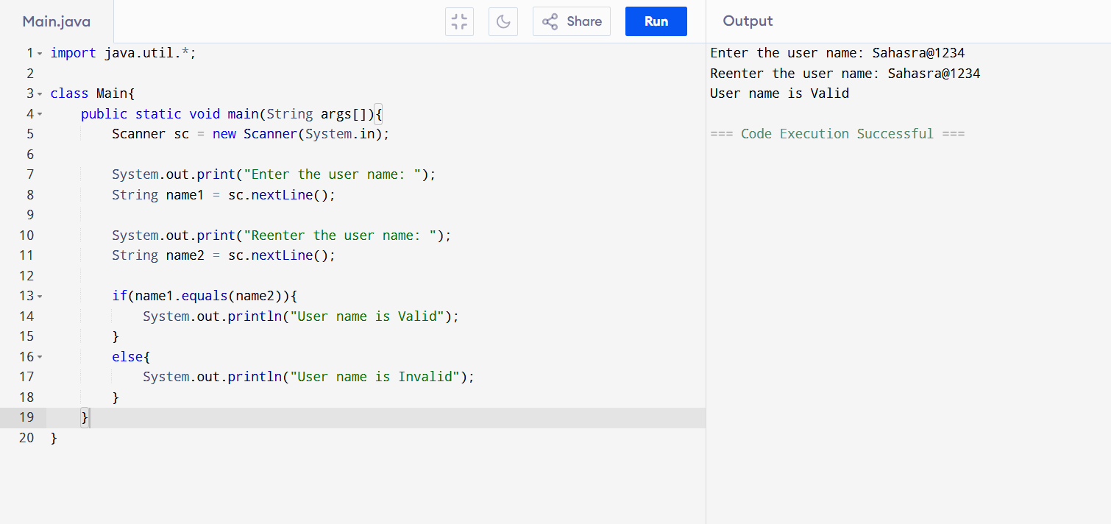

4. Sort Names (Ascending / Descending)

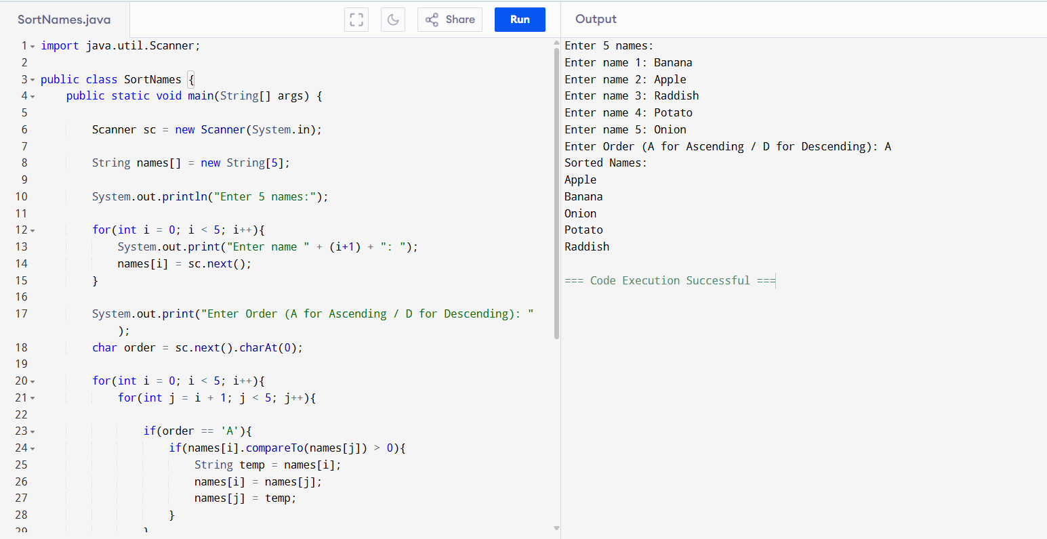

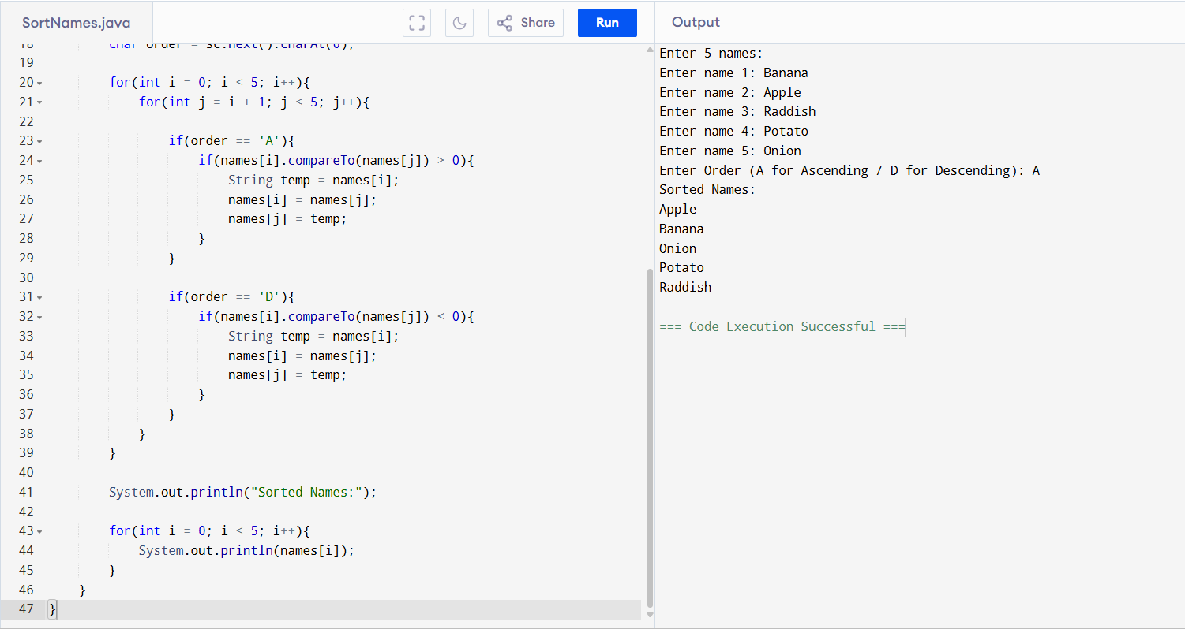

5. Print Special Characters and Count Them

